实验编号：4 **四川师大Android高级开发实验报告 2020**年 **4**月**10** 日

**计算机科学学院** 级 3 班 实验名称： 多界面纸牌游戏

姓名： 吴文娇 学号： 2017110543 指导老师： 樊相奎 实验成绩:_____

**实验 四 多界面纸牌游戏**

1. 实验目的及要求

目的：

(1) 采用对话框、菜单和 intent 实现多界面纸牌游戏。

(2) 掌握对象序列化和文件存储;

要求：

(1) 认真填写实验报告，要求附加部分运行界面和主要代码;

(2) 对设计好的程序，检查输出是否符合预期，如有错请分析错误原因并解决;

1. 实验内容

(1) V:修改界面，增加重玩、历史信息等功能，界面切换实现左右划入效果;

(2) C:控制器代码做适当调整，增加对话框、菜单、Intent 等功能;

(3) 对象序列化:要求可以存储玩牌历史信息;

1. 实验主要流程、基本操作或核心代码、算法片段（该部分如不够填写，请另加附页）

***MainActivity.java***

**package** com.example.liguiyang.firstdemo;  
  
**import** android.app.Activity;  
**import** android.content.Context;  
**import** android.content.Intent;  
**import** android.support.v7.app.AppCompatActivity;  
**import** android.os.Bundle;  
**import** android.text.Layout;  
**import** android.util.Log;  
**import** android.view.LayoutInflater;  
**import** android.view.View;  
**import** android.view.ViewGroup;  
**import** android.view.Window;  
**import** android.widget.BaseAdapter;  
**import** android.widget.Button;  
**import** android.widget.GridView;  
**import** android.widget.LinearLayout;  
**import** android.widget.SeekBar;  
**import** android.widget.SimpleAdapter;  
**import** android.widget.TextView;  
**import** android.widget.Toast;  
  
**import** com.example.liguiyang.firstdemo.model.Card;  
**import** com.example.liguiyang.firstdemo.model.CardMatchingGame;  
**import** com.example.liguiyang.firstdemo.model.PlayingCard;  
**import** com.example.liguiyang.firstdemo.model.PlayingDeck;  
  
**import** java.util.ArrayList;  
  
**public class** MainActivity **extends** Activity {  
 **private** CardMatchingGame **game**;  
 **private** ArrayList<CardMatchingGame> **games** = **new** ArrayList<CardMatchingGame>();  
  
 **private int numcards** = 24;  
  
 **private** CardAdapter **cardAdapter**;  
 **private** TextView **tvplay**;  
 **private** SeekBar **seekBar**;  
  
 **private static final** String ***TAG*** = **"MainActivity"**;  
 @Override  
 **protected void** onCreate(Bundle savedInstanceState) {  
 **super**.onCreate(savedInstanceState);  
 requestWindowFeature(Window.***FEATURE_NO_TITLE***);  
 setContentView(R.layout.***cardgame***);  
 **if**(savedInstanceState!=**null**){  
 **game**= (CardMatchingGame) savedInstanceState.getSerializable(**"game"**);  
 }**else**{  
 **game** = **new** CardMatchingGame(**numcards**);  
 }  
 GridView gridView = (GridView) findViewById(R.id.***gridView***);  
  
 **cardAdapter** = **new** CardAdapter(**this**, **game**);  
 gridView.setAdapter(**cardAdapter**);  
  
 **tvplay** = (TextView) findViewById(R.id.***detail***);  
 **seekBar** = (SeekBar) findViewById(R.id.***seekbar***);  
 **seekBar**.setOnSeekBarChangeListener(**new** SeekBar.OnSeekBarChangeListener() {  
 @Override  
 **public void** onProgressChanged(SeekBar seekBar, **int** progress, **boolean** fromUser) {  
 **if**(fromUser) {  
 **if** (progress >= **game**.**playHistories**.size() - 1)  
 progress = **game**.**playHistories**.size() - 1;  
 **tvplay**.setText(**game**.**playHistories**.get(progress));  
 }  
 }  
  
 @Override  
 **public void** onStartTrackingTouch(SeekBar seekBar) {  
  
 }  
  
 @Override  
 **public void** onStopTrackingTouch(SeekBar seekBar) {  
  
 }  
 });  
  
 updateUI();  
  
 Log.*d*(***TAG***, **"onCreate: "**);  
 }  
  
 @Override  
 **protected void** onRestart() {  
 **super**.onRestart();  
 Log.*d*(***TAG***, **"onRestart: "**);  
 }  
  
 @Override  
 **protected void** onStart() {  
 **super**.onStart();  
 Log.*d*(***TAG***, **"onStart: "**);  
 }  
  
 @Override  
 **protected void** onResume() {  
 **super**.onResume();  
 Log.*d*(***TAG***, **"onResume: "**);  
 }  
  
 @Override  
 **protected void** onPause() {  
 **super**.onPause();  
 Log.*d*(***TAG***, **"onPause: "**);  
 }  
  
 @Override  
 **protected void** onStop() {  
 **super**.onStop();  
 Log.*d*(***TAG***, **"onStop: "**);  
 }  
  
 @Override  
 **protected void** onDestroy() {  
 **super**.onDestroy();  
 Log.*d*(***TAG***, **"onDestroy: "**);  
 }  
  
 @Override  
 **protected void** onSaveInstanceState(Bundle outState) {  
 **super**.onSaveInstanceState(outState);  
 Log.*d*(***TAG***, **"onSaveInstanceState: "**);  
 outState.putSerializable(**"game"**,**game**);  
 }  
  
 **public void** reset(View v) {  
 **if** (**game**.isStart()) {  
 **game**.finish();  
 **games**.add(**game**);  
  
 **game** = **new** CardMatchingGame(**numcards**);  
 **cardAdapter**.setGame(**game**);  
  
 updateUI();  
 }  
 }  
  
  
 **private void** updateUI() {  
 **cardAdapter**.notifyDataSetChanged();  
 TextView tv = (TextView) findViewById(R.id.***testText***);  
 tv.setText(**"Score:"** + **game**.getScore());  
 **if**(**game**.**playHistories**.size()>0){  
 **tvplay**.setText(**game**.**playHistories**.get(**game**.**playHistories**.size()-1));  
 **seekBar**.setMax(**game**.**playHistories**.size()-1);  
 **seekBar**.setProgress(**seekBar**.getMax());  
 }**else**{  
 **seekBar**.setProgress(0);  
 **tvplay**.setText(**""**);  
 }  
 }  
  
  
 **class** CardAdapter **extends** BaseAdapter {  
 **private** MainActivity **context**;  
 **private** CardMatchingGame **game**;  
  
  
 **public** CardAdapter(MainActivity context, CardMatchingGame game) {  
 **this**.**context** = context;  
 **this**.**game** = game;  
  
 }  
  
 **public void** setGame(CardMatchingGame game){  
 **this**.**game** = game;  
 }  
  
  
 @Override  
 **public int** getCount() {  
 **return game**.count();  
 }  
 @Override  
 **public** Object getItem(**int** position) {  
 **return game**.cardAtIndex(position);  
 }  
 @Override  
 **public long** getItemId(**int** position) {  
 **return** position;  
 }  
 @Override  
 **public** View getView(**final int** position, **final** View convertView, ViewGroup parent) {  
 Button cardButton;  
 **if** (convertView == **null**) {  
 View view = LayoutInflater.*from*(**context**).inflate(R.layout.***card***, **null**);  
 cardButton = (Button) view.findViewById(R.id.***button_card***);  
 } **else** {  
 cardButton = (Button) convertView;  
 }  
  
 Card card = **game**.cardAtIndex(position);  
 **if** (card.isChosen()) {  
 cardButton.setText(card.getContents());  
 cardButton.setBackgroundResource(R.drawable.***blankcard***);  
 } **else** {  
 cardButton.setText(**""**);  
 cardButton.setBackgroundResource(R.drawable.***stanfordtree***);  
 }  
  
 cardButton.setOnClickListener(**new** View.OnClickListener() {  
 @Override  
 **public void** onClick(View v) {  
 **game**.chooseCardAtIndex(position);  
 **context**.updateUI();  
 }  
 });  
 cardButton.setEnabled(!card.isMatched());  
 **return** cardButton;  
 }  
 }  
 **public void** history(View v){  
 Intent intent = **new** Intent(MainActivity.**this**,GameHistoryActivity.**class**);  
 intent.putExtra(**"gamehistory"**,**games**);  
 startActivity(intent);  
 *//动画切换* overridePendingTransition(R.anim.***slide_in_right***,R.anim.***slide_out_left***);  
 }  
}

1. 实验结果的分析与评价（该部分如不够填写，请另加附页）

初始：

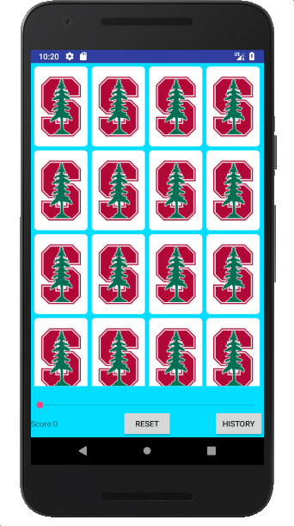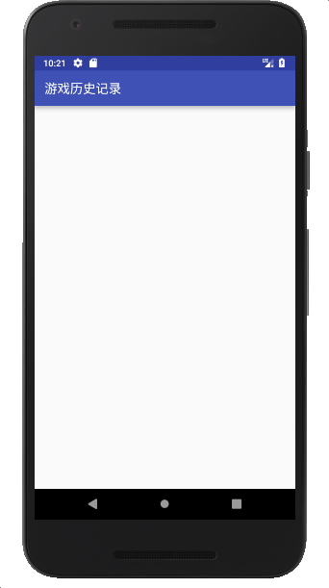

第一轮：

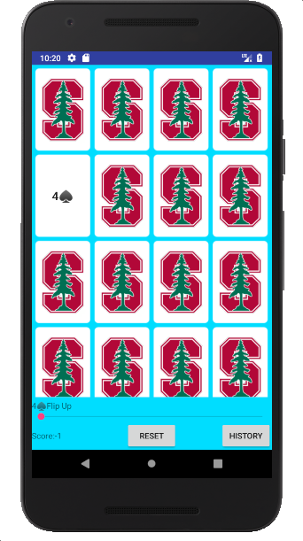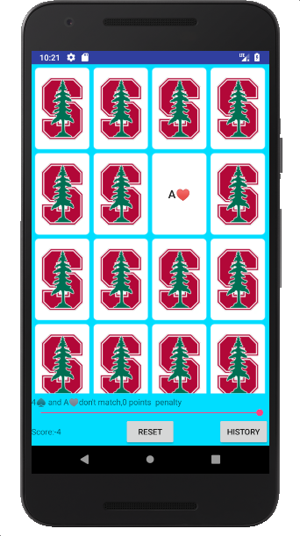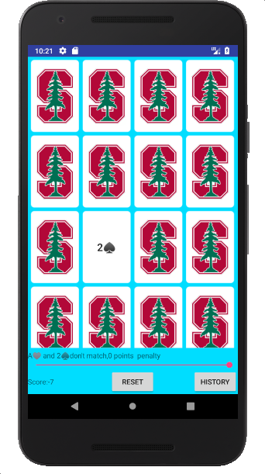

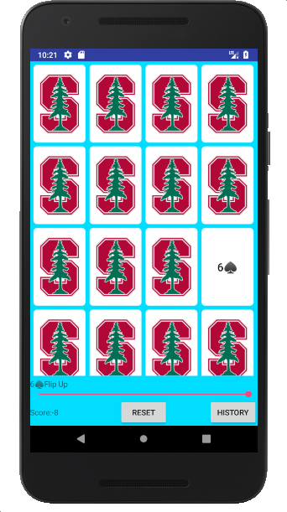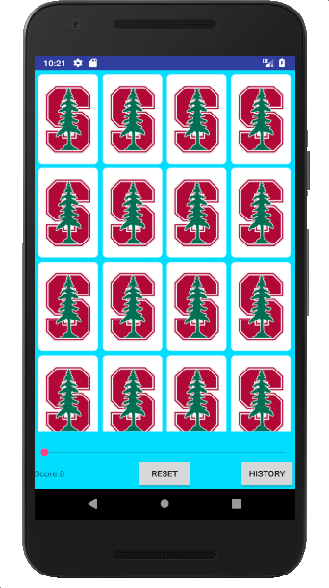

游戏记录：

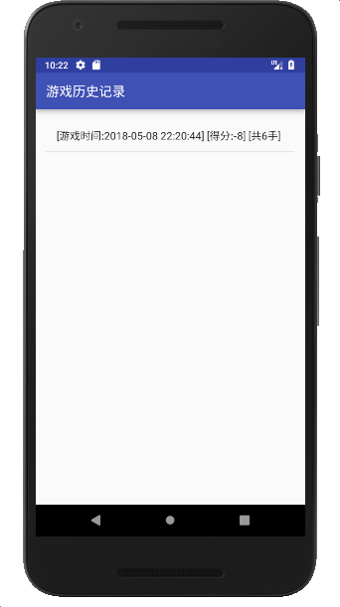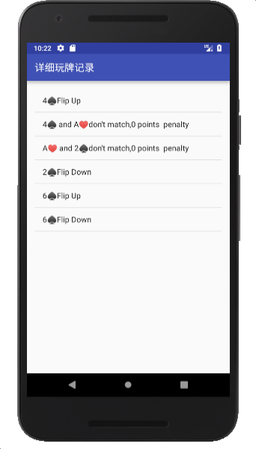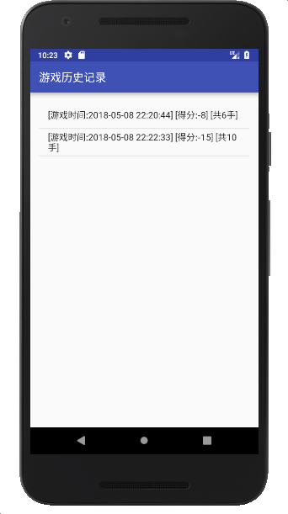

注：实验成绩等级分为（90－100分）优，（80－89分）良，(70-79分)中，（60－69分）及格，（59分）不及格。